|  |  |  |  |
| --- | --- | --- | --- |
|  | | |  |
|  | | | |
|  |  | Holtzwarth | |
| Clément | |

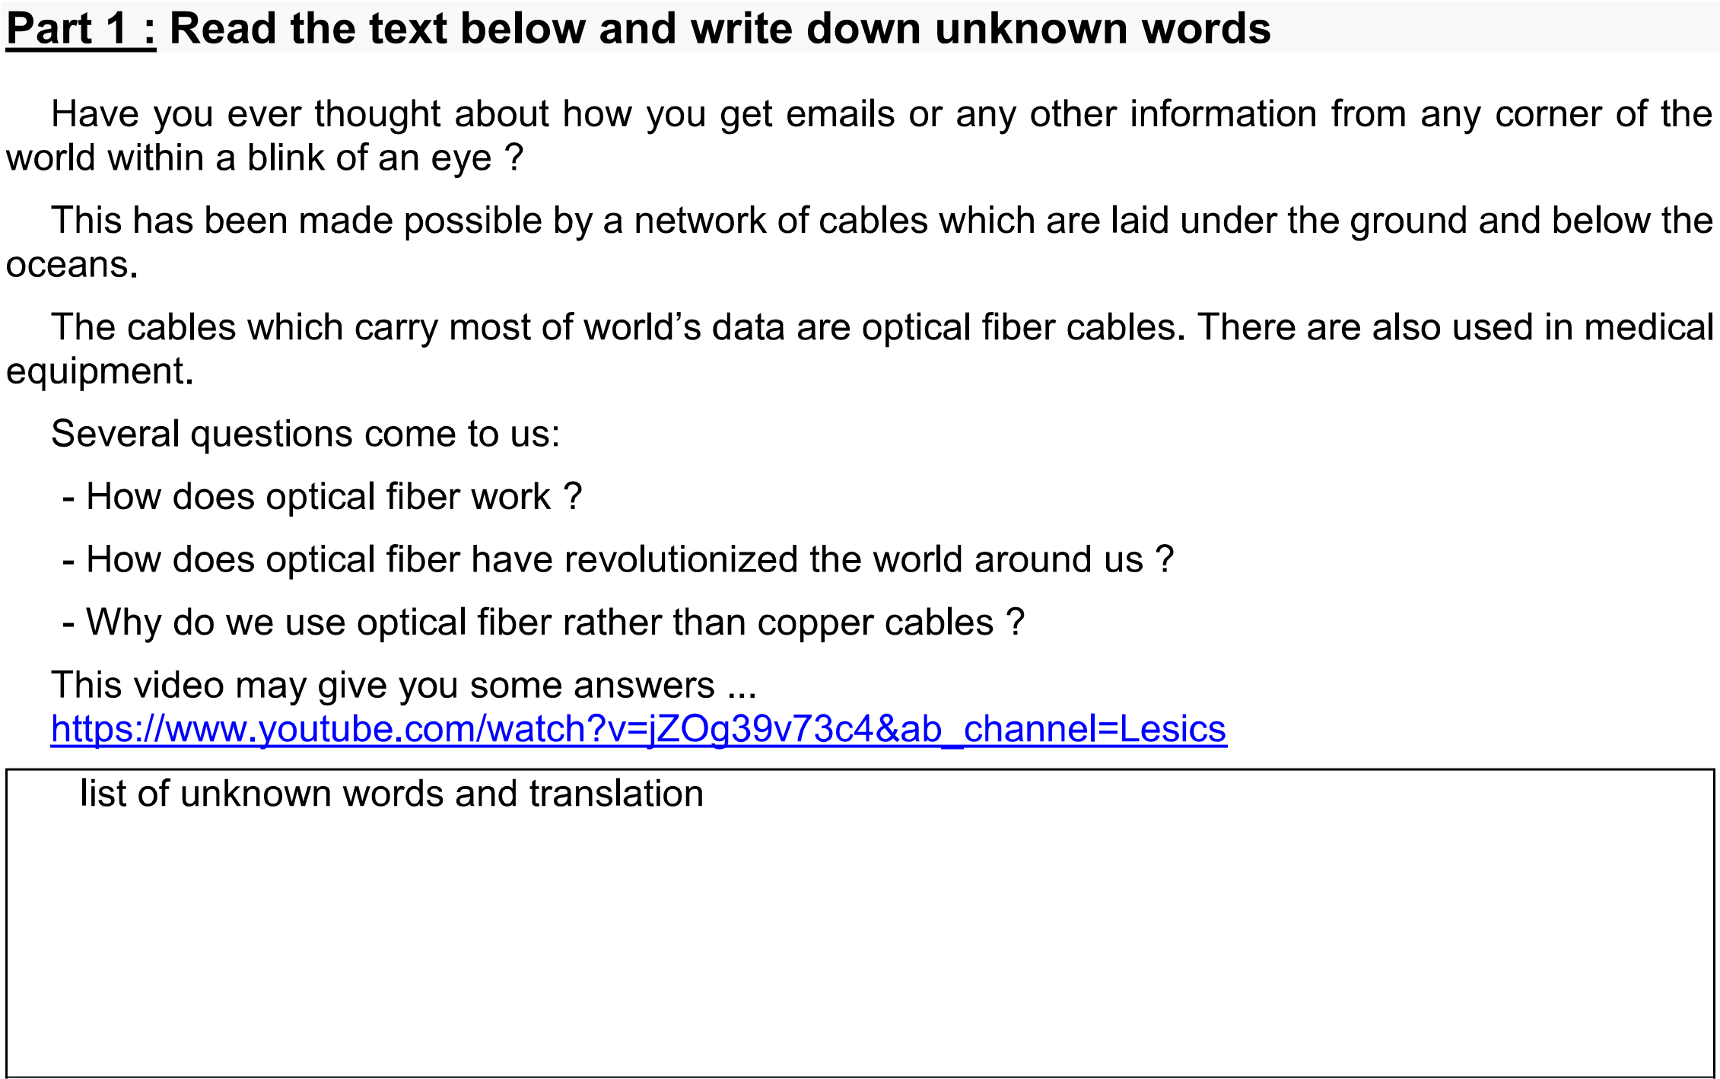

https://www..youtube.com/watch?v=jZOg39v73c4&ab_channel=Lesics

